PEOPLE’S DEMOCRATIC REPUBLIC OF ALGERIA
MINISTRY OF HIGHER EDUCATION AND SCIENTIFIC RESEARCH
UNIVERSITY M’HAMED BOUGARA OF BOUMERDES
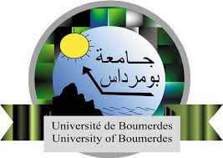
Faculty of Technology
Doctoral Thesis
Presented by:
………………………………..
Submitted for the Fulfilment of the Requirements of the DOCTORAT-LMD degree in
Field: …………………………………
Specialty: …………………………….

….title…….
In front of a jury composed of
President
Supervisor
Examiner
Examiner
Examiner

Academic Year: 2024/20225

